Nature Cycles
Diagrams that Explain the cycles are available in the following link: https://students.ga.desire2learn.com/d2l/lor/viewer/viewFile.d2lfile/1798/12675/ecology025.html
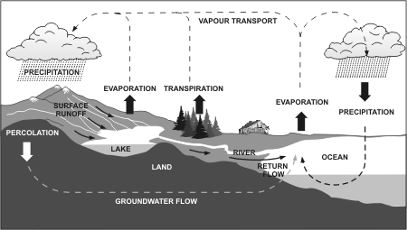
The water (Hydrologic) Cycle
Availability of water determines the diversity of organisms in an ecosystem. Water is crucial to Life. Cells contain 70 - 90 % water.
Process:
A. EVAPORATION: from lakes, rivers, and oceans.
B. TRANSPIRATION: from organisms (plants and animals)
C. CONDENSATION: Cloud Formation
D. PRECIPITATION: Rain, Snow, Sleet, Hail.
E. RUN OFF, or RETURNED back into the Cycle.
Carbon Cycle
Photosynthesis and cellular respiration form the basis of the carbon cycle. Carbon is found in all of the major macromolecules (carbohydrates, nucleic acids, proteins and lipids) which are necessary for all living systems.
There are five major reservoirs of carbon:
- the atmosphere
- the terrestrial biosphere
- oceans
- ocean sediments
- The earth's interior.

Processes of the Carbon Cycle:
- In the atmosphere, carbon is attached to some oxygen in a gas called carbon dioxide.
- Plants use carbon dioxide and sunlight to make their own food and grow. The carbon becomes part of the plant (photosynthesis)
- Plants and organisms that die (decomposition) are buried may turn into fossil fuels made of carbon like coal and oil over millions of years.
- Plants and animals return some Carbon to the atmosphere through cellular respiration
- When humans burn fossil fuels (combustion), most of the carbon quickly enters the atmosphere as carbon dioxide.
- Volcanic Eruptions and geothermal vents: carbon from deep within the earth's interior is brought back to the surface during eruptions of steam, gasses and lava
6
3

Nitrogen Cycle
- ALL organisms need nitrogen to make proteins and nucleic acids.
- Most nitrogen is found in the atmosphere (80%) as N2, and most living organisms need a bacteria or lightning to absorb nitrogen
- Nitrogen-fixing bacteria (Cyanobacteria and Rhizobium) live in the soil and in the roots of beans, peas, clover, and alfalfa. These bacteria can transform the nitrogen in a usable element
NITROGEN FIXATION
- Is the conversion of nitrogen gas to ammonia; Ammonia can be absorbed by plants from the soil, and used to make proteins.
NITROGEN FIXATION THROUGH LIGHTNING: nitrogen gas is converted to nitrates by lightning
NITRIFICATION
- Bacteria convert ammonia to nitrates that plants can utilize more easily
ASSIMILATION:
- Consumers obtain nitrogen from the plants and animals ingest the nitrogen from the plants
AMMONIFICATION.
- Decomposers break down the nitrogen from remains of dead plants and animals, waste products (urine, feces) to form ammonia
DENITRIFICATION
- Anaerobic bacteria (chemoautotrophs) break down nitrates and release nitrogen gas back into the atmosphere.

